**Homework 03: Fundamental Concepts III**

**PHYS550 – Quantum Mechanics I**

**Gabriel M Steward**

**September 15-20, 2021**

***Additional Texts Referenced: Introduction to Quantum Mechanics, Griffiths and Schroeter***

**Problem 1.20**

*a) The simplest way to derive the Schwarz inequality goes as follows. First, observe*



*for any complex number λ; then choose λ in such a way that the preceding inequality reduces to the Schwarz inequality.*

We are all but given this part in the text itself: λ needs to be set to:



So we substitute and start working with bra-ket arithmetic.

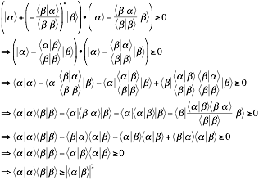

Which is the Schwarz inequality.

*b) Show that the equality sign in the generalized uncertainty relation holds if the state in question satisfies*



*with λ purely* ***imaginary****.*

The generalized uncertainty relation that has an equals sign is equation 1.156:



Where we remember that ∆A=A-<A>. We also recall that [A,B] = [∆A,∆B]. By 1.34, we establish that ∆A = λ∆B. However, we also need the inverse:



Note the sign flip on the lambda: this is only true because it is *fully imaginary*. If it was fully real there would be no sign flip.

Anyway, we now expand our relation and attempt to prove the equality.

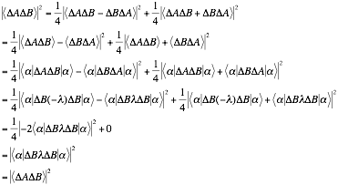

And we have our desired result.

This also holds true for the more general uncertainty relation.



Which we know is true by 1.152.

*c) Explicit calculations using the usual rules of wave mechanics show that the wave function for a Gaussian wave packet given by*



*satisfies the minimum uncertainty relation*



*Prove that the requirement*



*is indeed satisfied for such a Gaussian wave packet, in agreement with b).*

It may help to work with more familiar wave functions than bras and kets, so let’s restate some of the above in the appropriate form:





The minimum uncertainty relation remains the same as ∆x and ∆p are operators all their own.

Let us start with the basic “x” and “p” operators. Position translates directly: it is just x. Momentum is given by –iћ(∂/∂x). Following this, ∆x is  and ∆p is . Since the expected values are contained within the wave function, we may not even have to find them explicitly and can just work from here. Thus the requirement becomes:



To get much further we need to evaluate the derivative of the wavefunction. Let’s tackle that separately as it is not a particularly simple wavefunction.

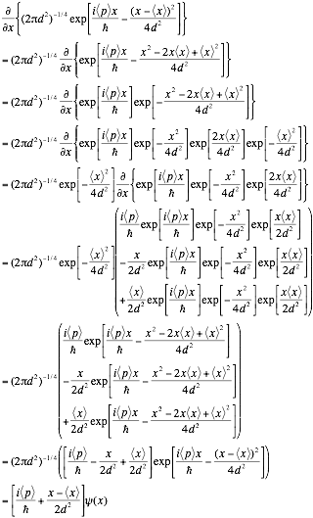

The simple answer makes it clear we took way too many steps to accomplish this, but at least it gives us confidence that the answer is correct.

Putting this back into our relation nets us:

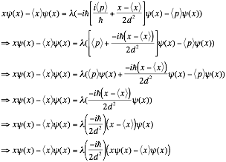

Which is true if λ = 2d2/(-iћ). This is a purely imaginary value, which is what we sought to show. Thus, our work here is done.

**Problem 1.21**

*a) Compute*



*where the expectation value is taken for the SZ+ state. Using your result, check the generalized uncertainty relation*



*with A->Sx, B->Sy.*

Start by finding the expectation value of Sx.



Sensible: if we are spin-z up the chances of being spin-z are equally up or down, so it goes to zero. The square expectation value is a little different:



Meanwhile the square is ћ2/4. Since the normal expectation is zero, this IS the dispersion.

|  |
| --- |
|  |

Logically, we should assume the same values for Sy. However, let’s evaluate it explicitly just to be sure.



The values are indeed the same.

Now we evaluate [A,B] or, more accurately [Sx,Sy]



And now we find the expectation value…



Which, if we insert back into our uncertainty relation with our previous values:



Which is exactly what we sought to show.

*b) Check the uncertainty relation with A->Sx, B->Sy for the Sx+ state.*

Sx+ is given by the vector (1/√2, 1/√2). Essentially we just repeat the above steps, but with this instead of Sz+.

Start by finding the expectation value of Sx.



Which is as it should be since if we know we are x-spin-up, it’s guaranteed. As for the square:



It has not changed from the previous part. This provides us a dispersion:



As expected: we should be *guaranteed* to be in spin-x-up.

This means we don’t even need to bother to calculate the dispersion of Sy as we’ll be multiplying it by zero in the final function anyway. From our previous part we also already know [Sx,Sy], which does not change here. So we just need to find its expectation value…



Which, if we insert back into our uncertainty relation with our previous values:



This is exactly what one expects when measuring something we just measured. We already know it’s in Sx+, so there’s no uncertainty about it!